THE SUPER SIX OF BETTER TOURISM BUSINESS

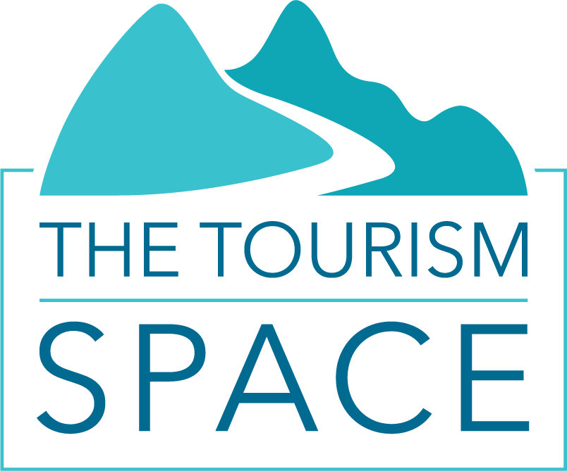

The Super Six of Better Tourism Business are a set of six objectives that provide a framework for creating businesses and destinations that last:
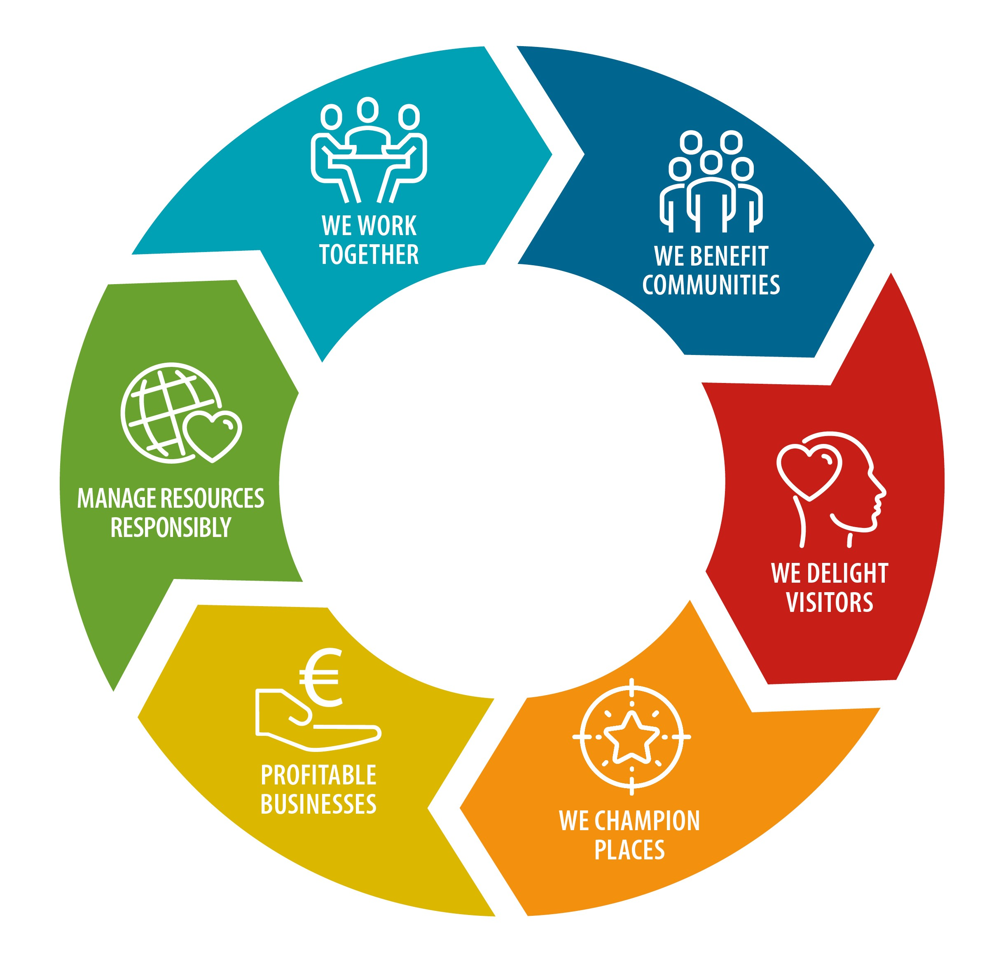
- We build profitable businesses that last
- We manage resources responsibly
- We benefit communities
- We delight and empower visitors
- We champion places
- We work together

SUPER 1: WE ARE BUILDING A PROFITABLE BUSINESS THAT LASTS | Yes, we already do this. | We’re working on this. | This is in our 1-3 year plan. | This doesn’t apply to us.
We have a documented business plan that spans at least 3 years.

We invest in systems and processes to improve our quality and productivity.

We have a set of financial metrics to track, analyse and manage our performance.
We prioritise cashflow and cash management.

We invest in ourselves and our team to improve leadership and business management (e.g. through training, mentoring, coaching, conferences…)
SUPER 2: WE TAKE CLIMATE ACTION TO REDUCE OUR EMISSIONS AND OUR COSTS | Yes, we already do this. | We’re working on this. | This is in our 1-3 year plan. | This doesn’t apply to us.
We have a plan to reduce our contribution to carbon emissions.

We measure and review the amount of energy consumed by our business each year.
We measure and review the amount of water consumed by our business each year.
We measure and review the amount of waste generated by our business each year.
We set targets and take actions to reduce our consumption of energy and water and the amount of waste generated by our business each year.

SUPER 3: WE BENEFIT COMMUNITIES | Yes, we already do this. | We’re working on this. | This is in our 1-3 year plan. | This doesn’t apply to us.
Our business leads, supports or contributes to at least one community project every year.

Our business provides information on local businesses, products, services, attractions or activities to guests through our website or personal communications.
Our business provides employment in the region.

We support employment in our region by buying produce or services from local providers, producers and retailers where possible.
SUPER 4: WE DELIGHT AND EMPOWER VISITORS | Yes, we already do this. | We’re working on this. | This is in our 1-3 year plan. | This doesn’t apply to us.
We actively encourage visitors to leave reviews or provide feedback to us directly.

We monitor visitor satisfaction levels, and continuously seek to enhance the visitor experience.

We tell visitors about the special value that their visit brings to our place and community.

We make our visitors aware of opportunities to offset their carbon footprint.

We make our visitors aware of contribution and give-back opportunities in the destination.
SUPER 5: WE CHAMPION PLACES | Yes, we already do this. | We’re working on this. | This is in our 1-3 year plan. | This doesn’t apply to us.
We actively participate in a natural or cultural heritage conservation project.

We support and promote a biodiversity or ecological restoration initiative.
We share and apply the principles of Leave No Trace or a similar landscape code in our business activities.
We share relevant and engaging information about our place with our guests to help them enjoy the unique nature of their stay with us.
We ensure that we are well-informed on the history and culture of our place so we can confidently and authentically share it with our visitors.
SUPER 6: WE COMMIT TO WORKING TOGETHER | Yes, we already do this. | We’re working on this. | This is in our 1-3 year plan. | This doesn’t apply to us.
We actively participate in local tourism networks or groups.

We engage with local community members and groups and seek their feedback on our activities.
We actively nurture relationships and constructive communications with our District Council.
We are actively engaged with Tourism NI.

